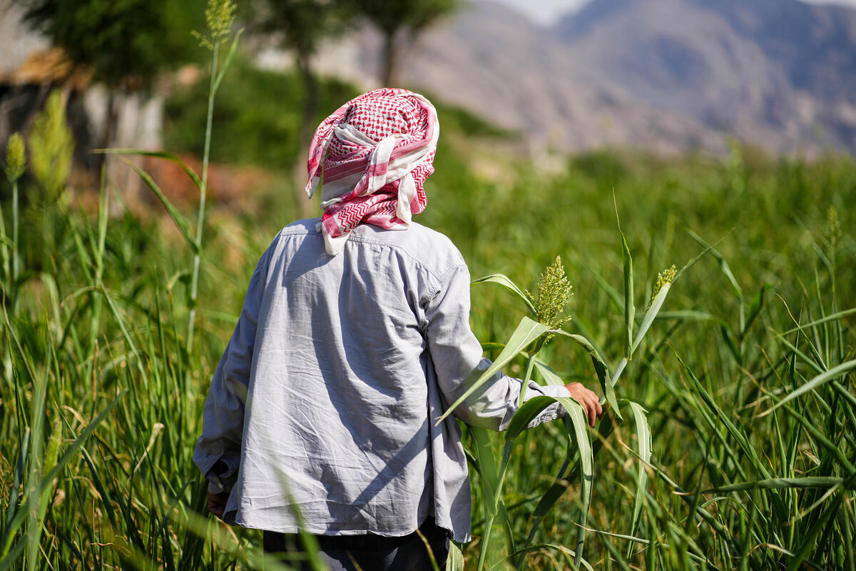



Selected Pilot Locations in Yemen - Anticipatory Action

Project Implementation Location Maps.
Figure 1:MAP SHOWING THE TWO SELECTED GOVERNORATES FOR PILOTING THE AA PROJECT
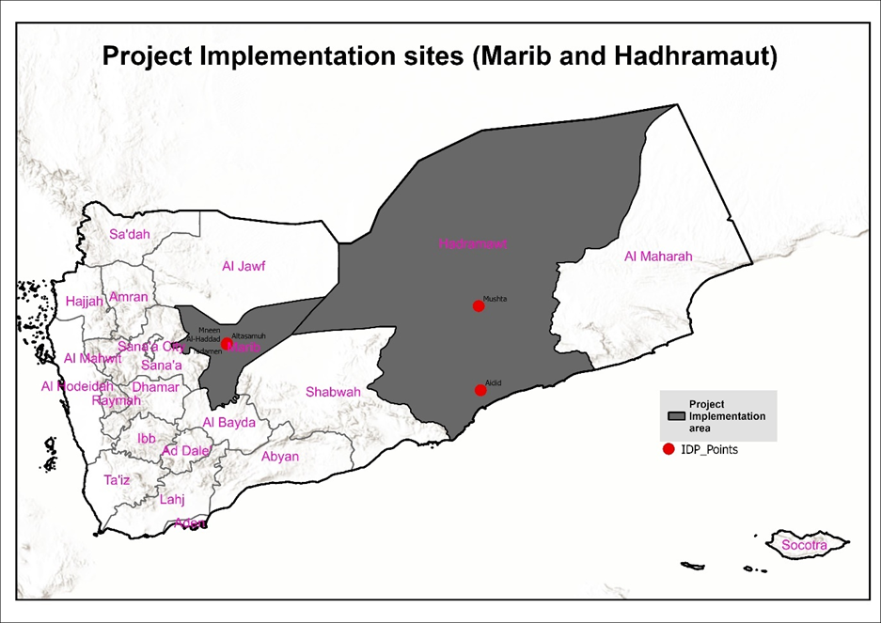
Selection criteria.
- Exposure to flood hazards.
Marib and Hadhramaut are consistently ranked among Yemen’s most flood-prone governorates, based on national flood susceptibility mapping and recent multi-hazard risk assessments. Marib faces recurrent flash floods due to its extensive wadi systems, such as Wadi Marib and Wadi Dhana, which cut through low-lying settlements and IDP sites. Hadhramaut is uniquely exposed to both inland wadi flooding (notably in Seiyun and Tarim) and coastal inundation (e.g., Mukalla and Ghayl Bawazir) driven by cyclonic storms and sea-level rise. Historical flood events such as the 2008 Hadhramaut floods and the 2020 Marib flash floods have caused severe displacement, infrastructure collapse, and loss of livelihoods. Crucially, the AA pilot will target vulnerable communities already living in documented high-risk flood zones, including three IDP settlements in Marib (Marib city and Marib Al Wadi) and two in Hadhramaut (Ghayl Bawazir and Tarim). Prioritizing these areas allows for preventive action that directly supports those most at risk of future flooding while building resilience among displaced and host populations. The flood risk maps developed for Marib and Hadhramaut indicate the flood prone areas and the location of the IDP camps in high flood susceptible areas.
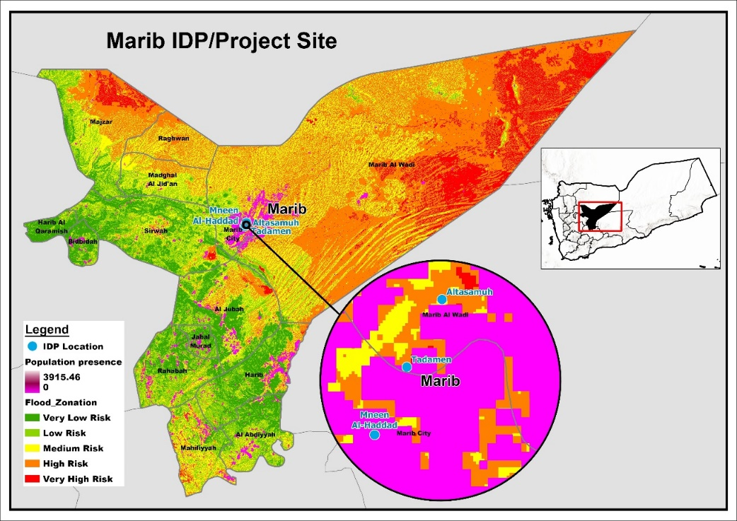
Figure 2: Flood risk zones map and targeted IDP Locations in Marib Governorate
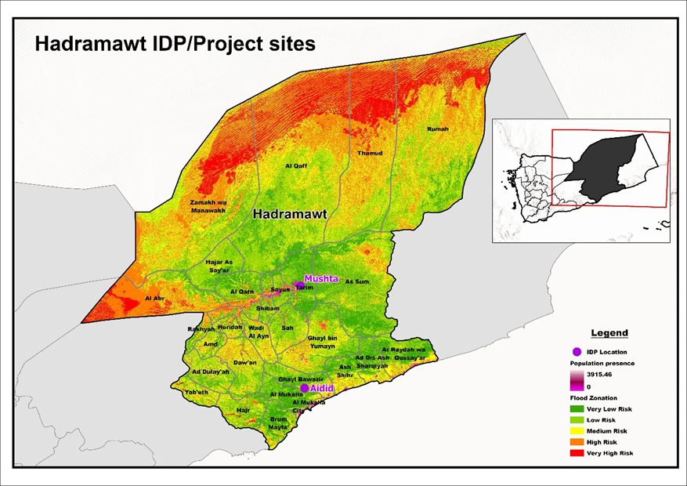
Figure 3: Flood risk zones map and targeted IDP Locations in Hadhramaut Governorate

- Food Security situation
Both governorates are experiencing acute levels of food insecurity, aggravated by climate shocks and displacement. According to the most recent IPC analysis (May–August 2025), 57% of Marib’s population and 41% of Hadhramaut’s are classified in IPC Phase 3 or above (Crisis or worse). Marib’s food insecurity is intensified by the presence of over 900,000 IDPs, many of whom rely on humanitarian aid and lack access to sustainable livelihoods. In Hadhramaut, while the overall stability is better, pockets of chronic food insecurity persist in coastal and interior areas, especially where water scarcity and market isolation prevail. The convergence of drought, flooding, and economic instability in both governorates exacerbates food access and availability. Integrating anticipatory action in these contexts will strengthen preparedness and allow timely interventions to prevent food security crises from escalating.
- Ongoing projects in the selected locations.
Marib and Hadhramaut are priority locations for several humanitarian and development actors, including WFP, FAO, UNDP, and national NGOs, creating a strong foundation for integrated programming. In Hadhramaut, resilience-building efforts—such as agricultural rehabilitation, irrigation repair, and livelihood diversification have gained momentum, particularly in the Wadi and coastal areas. In Marib, ongoing emergency food assistance, water and sanitation support, and protection interventions for IDPs are well-established. Launching the AA pilot in these areas ensures alignment with existing delivery mechanisms, facilitates coordination with established partners, and enables scaling through shared infrastructure. This continuity will not only maximize the impact of anticipatory actions but also reduce operational fragmentation and donor duplication.
- Institutional Stability and Governance Capacity (Proposed Additional Criterion)
Both governorates possess comparatively stronger local governance structures, which is critical for piloting complex anticipatory interventions. Marib’s local authorities have shown administrative resilience by maintaining basic service delivery and leveraging oil revenues for infrastructure investments. In Hadhramaut, district-level coordination mechanisms and functioning municipal services (e.g., in Mukalla and Seiyun) offer a conducive environment for rolling out early warning systems, cash transfers, and community-level preparedness initiatives. This administrative capacity improves the likelihood of project sustainability, government ownership, and policy uptake of anticipatory approaches—key success factors for pilot programs intended to scale nationally.

