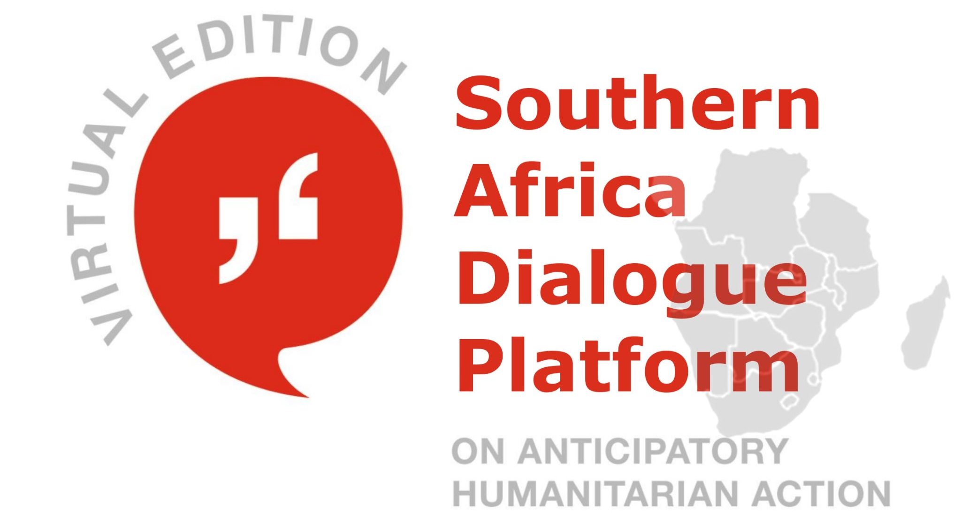

26 - 27 May 2021

Call for Sessions

This first Southern Africa Dialogue Platform will be organized virtually, and we aim at opening our virtual doors even more widely to our partners and experts and giving you the opportunity to shape the anticipation community as you intend to.

During the event, there will be several time slots available for (parallel) sessions. If you are interested in hosting a session (of +-30 to 60 minutes), please submit your session application by sending the below Session Application Form (p.3) completed back to us at jurg.wilbrink@ifrc.org and Lena.huhn@germanredcross.de at the earliest possible date but not later than 30th April 2021 so that we can consider your session and design the virtual Dialogue Platform accordingly. As the first day of the platform will be exploratory, and the second day co-design in nature, we are accepting sessions for the first day and please indicate if you would like to co-facilitate any discussions on the second day during the practical/co-design sessions. If your session is selected, we will invite you to submit the full details of your sessions at a later stage.

How to submit your session?

Themes

We are soliciting applications from our Anticipation community to contribute to the 1st Southern Africa Dialogue Platform by hosting a session that contributes to one or more of the following themes:

C1. Climate – Highlights of most recent developments and innovation in anticipatory action tools, guidelines and methodologies for climate and weather-related hazards. Example: Forecast-based Financing for Drought Guideline, Impact-based Forecasting for Early Action Guideline

C2. COVID-19 and other diseases – Learnings from anticipatory approaches and anticipatory financing relevant to the current COVID-19 and/or specifically on anticipating epidemics / other diseases.

C3. Conflict – Challenges and opportunities to apply anticipatory action in conflict settings.

C4. Collaboration – New initiatives and topics that demonstrate the value of cross-sector collaboration, such as understanding the value of anticipatory action to address disaster displacement, the use of earth observation for early action, strengthening coherence and coordination in disaster risk financing and many more.

We will select the session based on its link to anticipatory action and the four themes, trying to accommodate as many sessions as possible. If your session idea is similar to another one that we received, we might contact you and encourage you to host a session jointly.

Format

Your session can take various forms, including – but not limited to – panels, workshops, discussions, fishbowls, skills training, collaborative brainstorming – or any other interactive idea.

Technical Remarks

Media Sessions will be organized via Zoom (in Webinar mode). If you require other dialogue tools, e.g. separation in breakout groups, usage of Miro, Mentimeter etc. Please let us know in advance.
Language
The main language of the Dialogue Platform is English. Translation for Portuguese and French will be provided; your parallel session can be held in another language (e.g. French or Portuguese)

Submission Deadline

30th April 2021

Guiding Principles

To guide session hosts, the following are some principles to consider when designing your contribution:

Partnership building
We encourage cooperation and collaboration in southern Africa across sectors: public, private, academia and beyond. The Platform provides the opportunity for the “unusual suspects” to offer positive disruption. The most exciting partnerships develop needed solutions, incubate innovations and stimulate joint learning to address the challenges in our field of work.

Diversity of perspectives: listening to “two sides of the story”
We value willingness to present and/or critically engage with different – even opposing – opinions. By encouraging diversity of perspectives and expertise, the Platform seeks to be an inclusive and fair space for people from all kinds of background to engage on the topic of anticipatory action. It goes without saying, we expect all sessions to have good balance in gender and geographic representations.
Innovative, creative and interactive
We are looking for novel content and creative approaches to engage participants to not only ‘attend’ the session, but actively contribute in a meaningful way. Consider your format, methodology and technology to assure an interactive dialogue that will keep people interested and inspired. See these useful references on how to organize an engaging interactive session:
Virtually amazing
How to Host a Virtual Summit (and get away with it)

Depth over breadth
It’s better to be specific than superficial. Sessions should aim to get to the core of the issue at hand; and empower participants with tools and knowledge, rather than revisiting common talking points.

Allow time for interaction and discussions
Everyone at the Platform should have the opportunity to have their say. Sessions should devote plenty of time to open dialogues, constructive debates and exchanges of ideas. To capitalize on the wealth of experience and expertise at the Platform, we’d like sessions to encourage interaction between presenters and participants.

SESSION APPLICATION FORM
1st Southern Africa Dialogue Platform on Anticipatory Humanitarian Action -26th – 27th May 2021
Session Title

Availability for a  50 min Session, during these time frames | [Please indicate your availability for the session.] Central European Time  26th May 2021  □ 14:00-14:30h  □ 14:00-15:00h  □ 15:00-15:30h  □ 15:00-16:00h  or  □ only from ____ to ____
Session Language
Summary
(100 - 150 words, covering both topic as well as idea for session design)
Contact Person
Speaker(s) and/or Facilitator(s)
Hosting Organization
Tools  to be used (e.g. Mentimeter) | [Please indicate here if you need to divide your session into break out groups.]

